**ABSTRACT**

Agriculture is done in every country from ages. Agriculture is the science and art of cultivating plants. Agriculture was the key development in the rise of sedentary human civilization. Agriculture is done manually from ages. As the world is trending into new technologies and implementations it is a necessary goal to trend up with agriculture also. IOT plays a very important role in smart agriculture. IOT sensors are capable of providing information about agriculture fields. we have proposed an IOT and smart agriculture system using automation. The widespread usage of the internet from the last two decades has brought unlimited beneﬁts for organizations and citizens over the globe. The major beneﬁt of this innovation was the capability to producer and consumer services in real time. Recently, Internet of Things (IoT) is promising to provide the same beneﬁt through its innovative technologies and giving a way to enhance the user’s perception and ability by modifying the working environment. IoT oﬀers multiple solutions in diﬀerent domains such as healthcare, retail, traﬃc, security, smart homes, smart cities, and agriculture. IoT deployment in agriculture is considered the ideal solution because in this area there is a need for continuous monitoring and controlling of the moisture of the soil used for cultivation of crops.

This IOT based Agriculture monitoring system makes use of wireless sensor networks that collects data from different sensors deployed at various nodes and sends it through the wireless protocol. This smart agriculture using IOT system is powered by Arduino, it consists of Temperature sensor, Moisture sensor, water level sensor, DC motor and GPRS module. When the IOT based agriculture monitoring system starts it checks the water level, humidity and moisture level. It sends SMS alert on the phone about the levels. Sensors sense the level of water if it goes down, it automatically starts the water pump. If the temperature goes above the level, fan starts. This all is displayed on the LCD display module. This all is also seen in IOT where it shows information of Humidity, Moisture and water level with date and time, based on per minute. Temperature can be set on a particular level, it is based on the type crops cultivated. If we want to close the water forcefully on IOT there is button given from where water pump can be forcefully stopped.

**CONTENTS**

* **ACKNOWLEDGEMENT**
* **ABSTRACT**
* **CHAPTER-01**

INTRODUCTION………………………………………………………………………………………………………..**07**

* **CHAPTER-02**

LITERATURE REVIEW**………………………………………………………………………………………………08**

* **CHAPTER-03**

EXISTING SYSTEM**………………………………………………………………………………………………….09**

* **CHAPTER-04**

PROBLEM STATEMENT & OBJECTIVE**………………………………………………………………………10**

* **CHAPTER-05**

PROPOSED SYSTEM & BLOCK DIAGRAM**……………………………………………………………….…11**

* **CHAPTER-06**

COMPONENTS**……………………………………………………………………………………………………….13**

* **CHAPTER-07**

ALGORITHM**…………………………………………………………………………………………………………..18**

* **CHAPTER-08**

CIRCUIT DIAGRAM AND WORKING**………………………………………………………………………….20**

* **CHAPTER-09**

ADVANTAGES & DISADVANTAGES**………………………………………………………………………….22**

* **CHAPTER-10**

CONCLUSION & FUTURE SCOPE**………………………………………………………………………….....23**

* **CHAPTER-11**

FINAL MODEL OF IoT BASED SMART AGRICULTURE MONITORING SYSTEM……………...**24**

* **CHAPTER-12**

REFERENCES**………………………………………………………………………………………………………..…25**

* **THANK YOU……………………………………………………………………………………………………….……26**

**LIST OF FIGURES**

**LIST OF TABLES**

|  |  |  |  |  |  |  |  |  |  |  |  |  |  |  |  |  |  |  |  |  |  |  |  |  |  |  |  |  |  |  |  |  |  |  |  |  |  |
| --- | --- | --- | --- | --- | --- | --- | --- | --- | --- | --- | --- | --- | --- | --- | --- | --- | --- | --- | --- | --- | --- | --- | --- | --- | --- | --- | --- | --- | --- | --- | --- | --- | --- | --- | --- | --- | --- |
| |  |  |  | | --- | --- | --- | | FIGURE  NUMBER | TITLE | PAGE  NUMBER | | 1) | EXISTING SYSTEM | 9 | | 2) | BLOCK DIAGRAM | 12 | | 3) | Node MCU ESP8266 | 13 | | 4) | Soil Moisture Sensor | 14 | | 5) | DHT11 Sensor | 15 | | 6) | Submersible Mini Water Pump | 16 | | 7) | 12V LED Strip | 16 | | 8) | Blynk App | 17 | | 9) | Flowchart | 18 – 19 | | 10) | Circuit Diagram | 20 | | 11) | FINAL MODEL OF IoT BASED SMART AGRICULTURE MONITORING SYSYTEM | 24 | |  |
|  |  |
|  |  |
|  |  |
|  |  |
|  |  |
|  |  |
|  |  |

**CHAPTER 01**

**INTRODUCTION**

Agriculture is done in every country from ages. Agriculture is the science and art of cultivating plants. Agriculture was the key development in the rise of sedentary human civilization. Agriculture is done manually from ages. As the world is trending into new technologies and implementations it is a necessary goal to trend up with agriculture also. But now due to migration of people from rural to urban there is hindrance in agriculture. So to overcome this problem we have proposed an IOT and smart agriculture system. Where IOT plays a very important role in agriculture, IOT sensors are capable of providing information about agriculture fields. This IOT based Agriculture monitoring system makes use of wireless sensor networks that collects data from different sensor deployed at various nodes and sends it through the wireless protocol. And it is powered by Arduino. It consists of temperature sensor, humidity sensor, water level sensor, PIR sensor and GSM module. When the IOT based agriculture monitoring system starts it checks the water level, humidity and moisture level. It sends SMS alert to the phone about the levels of the water. And controlling these parameters are through any remote device or internet services and the operations are performed by interfacing sensor, Wi-Fi, camera with micro controller. This concept is created as a product and given to the farmer’s welfare.

As the world is trending into new technologies and implementations it is necessary goal to trend up in agriculture also. Agriculture is considered as the basis of life for the human species as it is the main source of food grains and raw materials. Where it plays vital role in the growth of country’s economy. It also provides large ample employment opportunities to the people. Growth in agriculture sector is necessary for the development of economic condition of the country. Unfortunately, many farmers still use the traditional methods of farming which results in low yielding of crops and fruits. But wherever automation had been implemented and human being had been replaced by automatic machineries, the yield has been improved. Hence there is need to implement modern science and technology in the agriculture sector for increasing the yield.

Where technology is rapidly growing and new inventions are being created day by day even then farmers are facing a lot of problem about their fields. This is the duty of an every individual to create an environment where farmers must feel comfort and good production.

**CHAPTER 02**

**LITERATURE REVIEW**

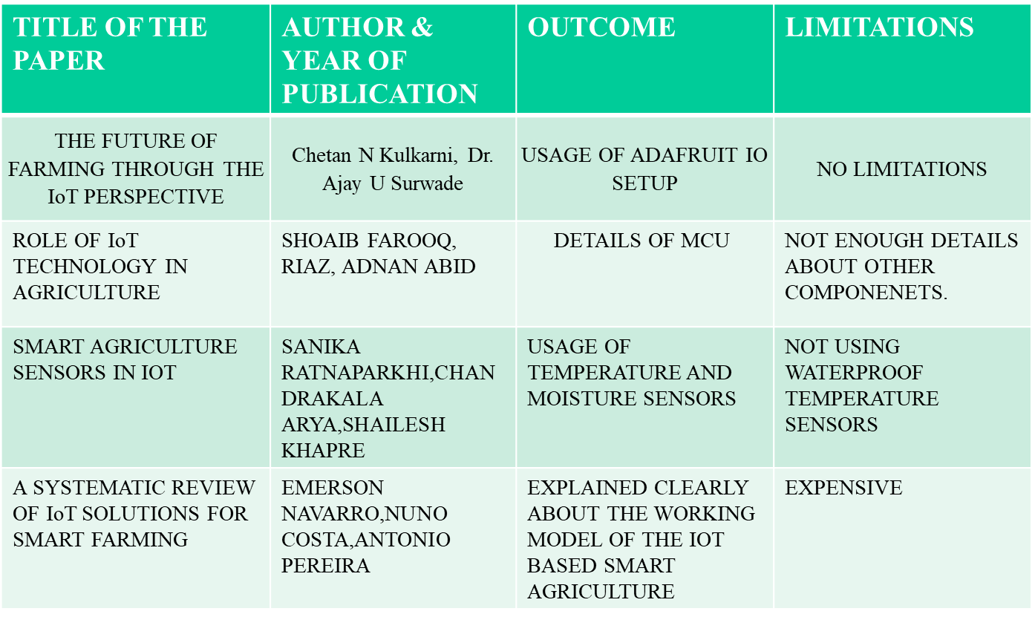

**CHAPTER 03**

**EXISTING SYSTEM**

* The existing system has been designed to check the moisture content present in the soil which helps in protecting the nutrients of the soil intact and save the water.

* If the soil moisture goes below a certain level, it automatically starts the water pump and if the soil moisture goes above a certain level, the water pump automatically stops without human presence.

*The system has a built in automatic plant irrigation system which sends alerts on mobile via SMS.

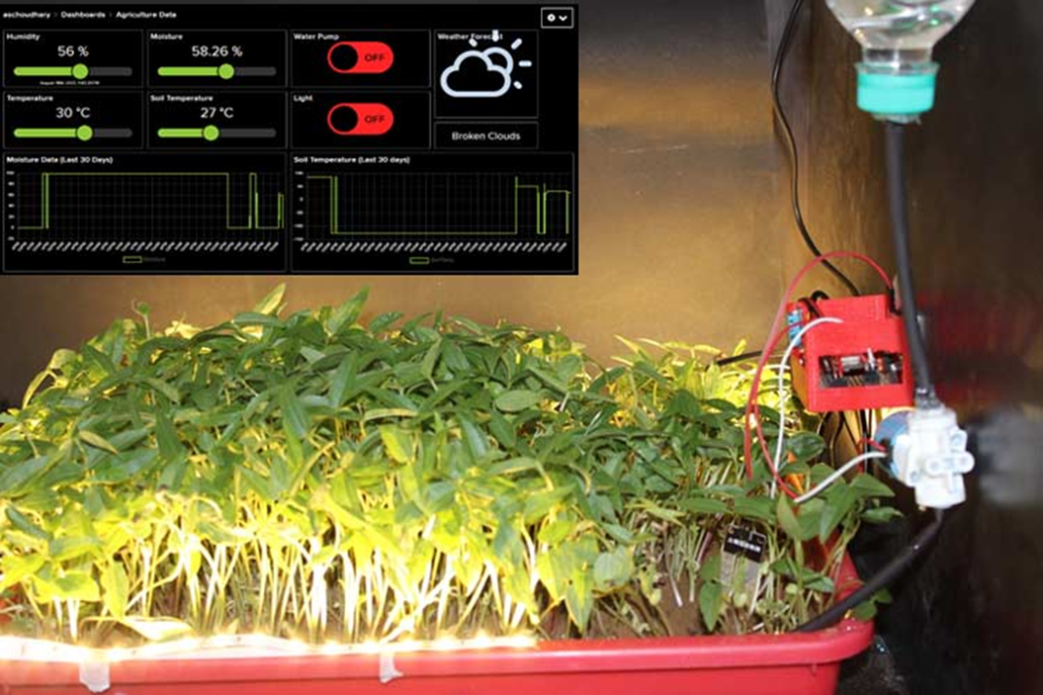

**CHAPTER 04**

**PROBLEM STAEMENT & OBJECTIVES**

* **PROBLEM STATEMENT:**
* The problem arises whenever there is any critical situation that cannot be handled at the specified time i.e., When the climate varies then automatically field parameters also suddenly changes. Whenever there is heavy rainfall or temperature varies this may become very hard to analyse the situation and it causes a major problem.
* Taking this as a problem into consideration, designing of IOT based agriculture monitoring system is very needed. This IOT server can be easily monitored from anywhere and comfortable to access the changes in the fields. We can monitor from anywhere through our mobile phone easily

based on the IOT servers and SMS alerts.

* **OBJECTIVES:**
* The objective of this project is to offer assistance to farmers in getting Live Data (Temperature, Humidity, Soil Moisture, Soil Temperature) for efficient environment monitoring which will enable them to increase their overall yield and quality of products. It then sends this data to the IoT cloud for live monitoring.
* The main objective of this paper is to design a IOT based agriculture monitoring system. This system acts a protect of the fields from various problems.

**CHAPTER 05**

**PROPOSED SYSTEM & BLOCK DIAGRAM**

* **PROPROSED SYSTEM:**
* In this project, we are going to build a Smart Farming System using IoT. The objective of this project is to offer assistance to farmers in getting live data (Temperature, Humidity, Soil Moisture, Soil Temperature) for efficient environment monitoring which will enable them to increase their overall yield and quality of products.
* When the IoT-based agriculture monitoring system starts, it checks the Soil moisture, temperature, humidity, and soil temperature. It then sends this data to the IoT cloud for live monitoring.

* We previously build Automatic Plant Irrigation System which sends alerts on mobile but doesn’t monitor other parameters.

* Apart from this, Rain alarm and soil moisture detector circuit will also be helpful in building Smart Agriculture Monitoring System.

* **BLOCK DIAGRAM:**

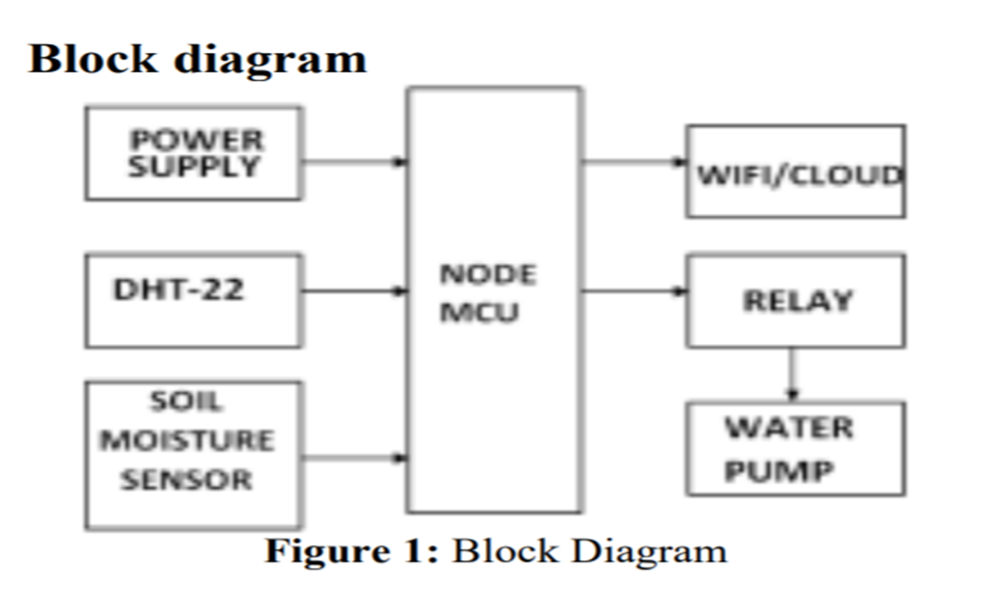

**CHAPTER 06**

**COMPONENTS**

* **HARDWARE COMPONENTS:**
* **Node MCU ESP8266:**

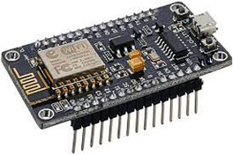 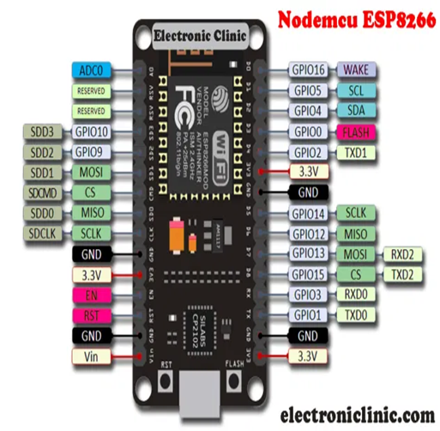

The Node MCU ESP8266 development board comes with the ESP-12E module containing the ESP8266 chip having Tensilica Xtensa 32-bit LX106 RISC microprocessor. This microprocessor supports RTOS and operates at 80MHz to 160 MHz adjustable clock frequency. Node MCU has 128 KB RAM and 4MB of Flash memory to store data and programs. Its high processing power with in-built Wi-Fi / Bluetooth and Deep Sleep Operating features make it ideal for IoT projects. Node MCU can be powered using a Micro USB jack and VIN pin (External Supply Pin). It supports UART, SPI, and I2C interface.

Its used in :

*Prototyping of IoT devices.

*Low power battery operated applications.

*Network projects.

*Projects requiring multiple I/O interfaces with Wi-Fi and Bluetooth functionalities.

* **Soil Moisture Sensor :**

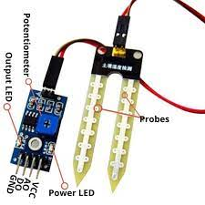

Soil moisture Indicator measures the volumetric water content in soil. It is used measure the rise and fall of the amount (or percentage) of water in the soil. This is an ideal and low cost agricultural tool for Farmers to keep plants/farms grow healthier. It helps farmers in irrigation scheduling and knowing the soil moisture status instantly (within 2-5 seconds).

Features:

*Instant indication of the soil moisture status.

*Indicates soil moisture level with more objectivity by different coloured LED’s.

*Saves water, current and time.

*Suitable for different types of soils.

*Suitable for use in nurseries, farms, potted plants, etc.

* **DHT11 Sensor :**

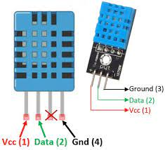

The DHT11 is a basic, ultra low-cost digital temperature and humidity sensor. It uses a capacitive humidity sensor and a thermistor to measure the surrounding air, and spits out a digital signal on the data pin (no analog input pins needed). Its fairly simple to use, but requires careful timing to grab data. The only real downside of this sensor is you can only get new data from it once every 2 seconds, so when using our library, sensor readings can be up to 2 seconds old. Compared to the DHT22, this sensor is less precise, less accurate and works in a smaller range of temperature or humidity, but its smaller and less expensive.

Specifications:

Operating Voltage: 3.5V to 5.5V

Operating current: 0.3mA (measuring) 60uA (standby)

Output: Serial data

Temperature Range: 0°C to 50°C

Humidity Range: 20% to 90%

Resolution: Temperature and Humidity both are 16-bit

Accuracy: ±1°C and ±1%

* **Submersible Mini Water Pump:**

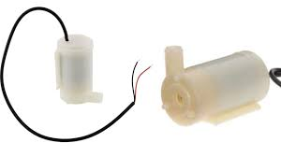

A mini submersible pump is a smaller version of the submersible water pumps which is lightweight and small size,it is used widely in household for cooking, cleaning and watering flowers.

Specifications:-

*Operating Voltage : 3 ~ 6V

*Operating Current : 130 ~ 220mA

*Flow Rate : 80 ~ 120 L/H

*Maximum Lift : 40 ~ 110 mm

*Continuous Working Life : 500 hours

*Driving Mode : DC, Magnetic Driving

*Material : Engineering Plastic

*Outlet Outside Diameter : 7.5 mm

*Outlet Inside Diameter : 5 mm

* **12V LED Strip:**

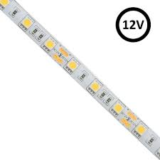 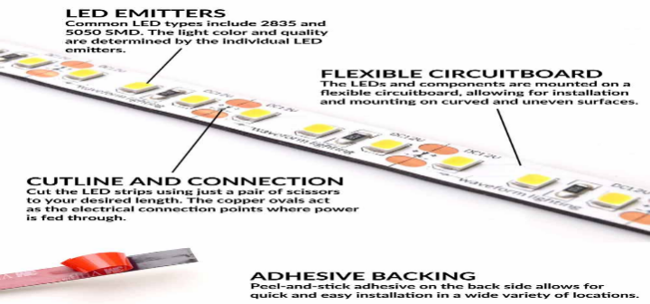

An LED strip light (also known as an LED tape or ribbon light) is a flexible circuit board populated by surface mounted light-emitting diodes (SMD LEDs) and other components that usually comes with an adhesive backing. Traditionally, strip lights had been used solely in accent lighting, backlighting, task lighting, and decorative lighting applications. Increased luminous efficacy and higher-power SMDs have allowed LED strip lights to be used in applications such as high brightness task lighting, fluorescent and halogen lighting fixture replacements, indirect lighting applications, ultraviolet (UV) inspection during manufacturing processes, set and costume design, and even growing plants.

* **SOFTWARE COMPONENT:**
* **BLYNK App:**

 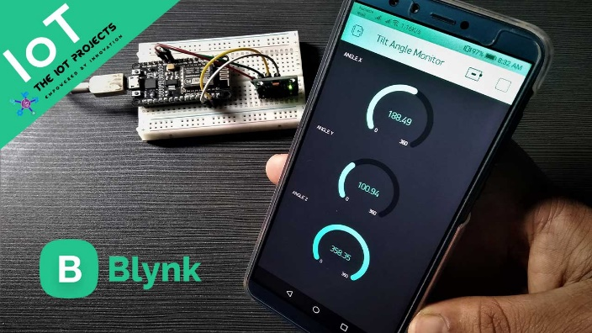

Blynk is a Platform with IOS and Android apps to control Arduino, Raspberry Pi and the likes over the Internet. It’s a digital dashboard where you can build a graphic interface for your project by simply dragging and dropping widgets.

Featurs of Blynk app –

* Cost-effective all-in software package you would need to run an IoT business

*White-label native iOS and Android apps for end-customers

*Powerful back-office to manage devices, users, organizations, and locations

*Cloud hosting and maintenance included

* Works with any hardware

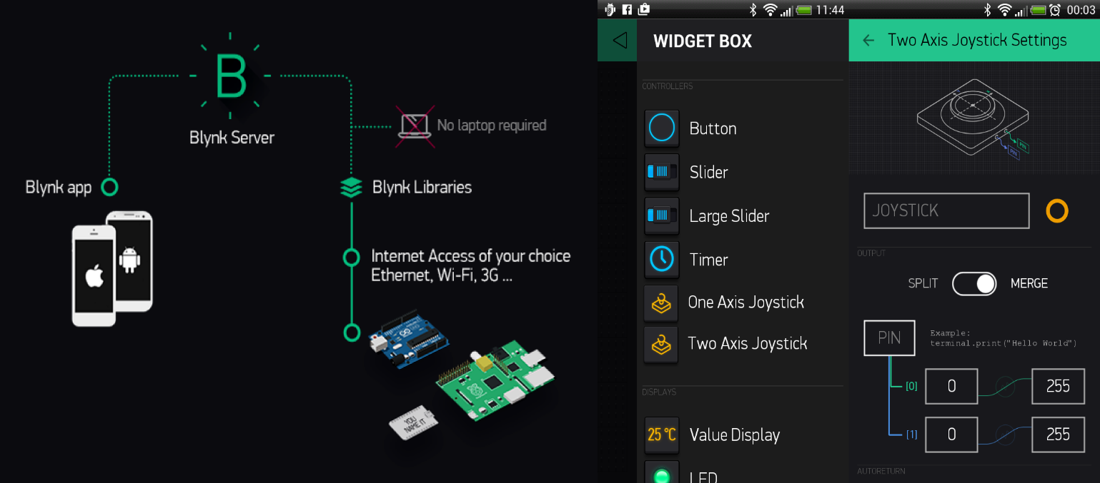

**CHAPTER 07**

**ALGORITHM / FLOWCHART**

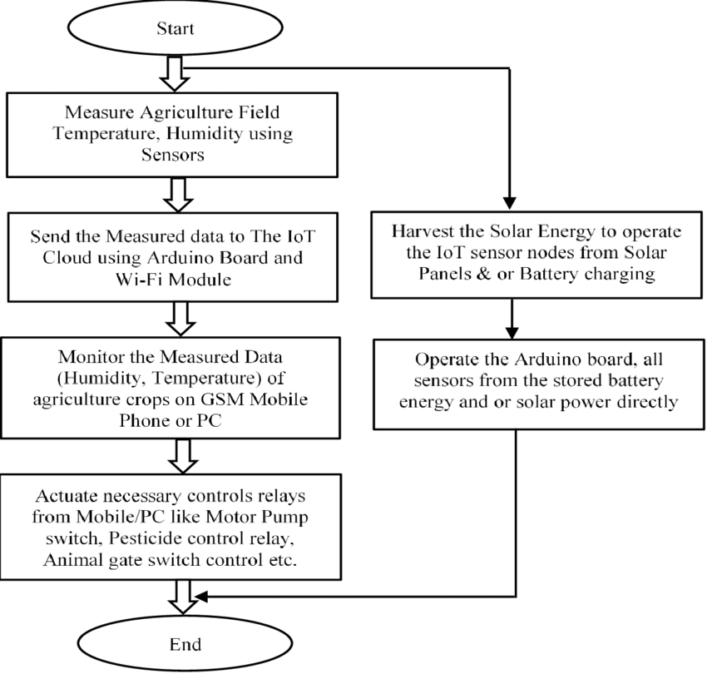

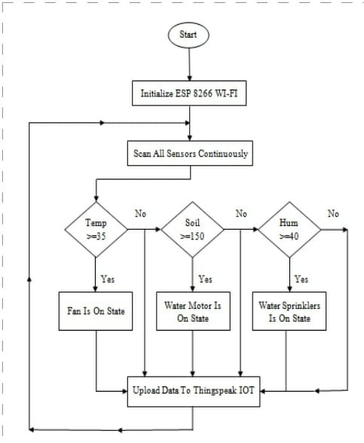

**CHAPTER 08**

**CIRCUIT DIAGRAM AND WORKING**

* **CIRCUIT DIAGRAM:**

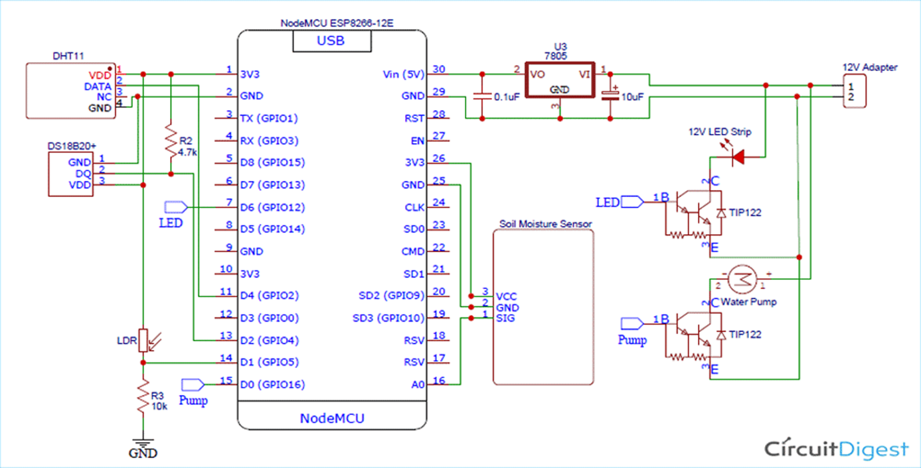

* **WORKING:**

* For plantation of crops irrigation and role of light plays an vital role. After implementation of the project in the plantation form firstly dht11 sensor is used to determine the temperature and humidity of atmosphere of plantation according to it a digital values are send to node MCU of d4 pin. Its operating power is 3.5V to 5.5V which is received from node MCU.

* DS18B20 is used to get precise value of temperature up to 9 to 12 digital values without using a AD conversion its operating voltage is same as dht11 sensor it is connected to d2 of node MCU.

* LDR sensor (light dependent resistor) it is used to measure the intensity of light which is the major factor of photosynthesis 0f plants in this sensor as the intensity of light increases the conductivity of LDR increases it is connected to d1 node MCU it is connected to d1 node MCU. Voltage regulator is used to get +5V.

*Soil moisture sensor which are used to determine amount of water content present in soil these also have water probes are connected to them so these can measure soil moisture on several locations. These are placed in plantation these are used as the input parameter of the node MCU.

* In node MCU which collects data from various devices and runs the code. Transfers data using wi-fi protocol , so if the moisture content is less than or equal to 25 which is detected by moist sensor then the 15V water pump automatically turns on other wise turn off automatically.

* Secondly when there is no light the LED strip blinks on automatically. After the execution of program at node MCU with given delay.

**CHAPTER 09**

**ADVANTAGES & DISADVANTAGES**

* **ADVANTAGES:**

* **Water Conservation** - Weather predictions and soil moisture sensors allow for water use only when and where needed.

* **Real-Time Data and Production Insight** - Farmers can visualize production levels, soil moisture, sunlight intensity and more in real time and remotely to accelerate decision making process.

* **Lowered Operation Costs** - Automating processes in planting, treatment and harvesting can reduce resource consumption, human error and overall cost.

\***Increased Quality of Production** - Analysing production quality and results in correlation to treatment can teach farmers to adjust processes to increase quality of the product.

* **Accurate Farm and Field Evaluation** - Accurately tracking production rates by field over time allows for detailed predicting of future crop yield and value of a farm.

* **Reduced Environmental Footprint** - All conservation efforts such as water usage and increased production per land unit directly affect the environmental footprint positively.

* **Remote Monitoring** - Local and commercial farmers can monitor multiple fields in multiple locations around the globe from an internet connection. Decisions can be made in real-time and from anywhere.

* **Equipment Monitoring** - Farming equipment can be monitored and maintained according to production rates, labor effectiveness and failure prediction.

* **DISADVANTAGES:**
* **Security -** As the IoT systems are interconnected and communicate over networks. The system offers little control despite any security measures, and it can be lead the various kinds of network attacks.
* **Privacy -** Even without the active participation on the user, the IoT system provides substantial personal data in maximum detail.
* **Complexity -** The designing, developing, and maintaining and enabling the large technology to IoT system is quite complicated.

**CHAPTER 10**

**CONCLUSION & FUTURE SCOPE**

* **CONCLUSION:**
* IoT will help to enhance smart farming. Using IoT the system can predict the soil moisture level and humidity so that the irrigation system can be monitored and controlled. IoT works in different domains of farming to improve time efficiency, water management, crop monitoring, soil management and control of insecticides and pesticides. This system also minimizes human efforts, simplifies techniques of farming and helps to gain smart farming. Besides the advantages provided by this system, smart farming can also help to grow the market for farmer with single touch and minimum effort.
* The proposed smart agriculture monitoring is very helpful for the famers, who is actually in need. Where GSM modem takes the information from the microcontroller and forwards the messages to the respective contact numbers. And Wi-Fi model sends the parameters to the IOT server by graphical method. Then farmer performs the necessary pre-cautions to the field.
* **FUTURE SCOPE:**
* GPS(Global Positioning System) can be integrated to provide specific location of the farmer and more accurate weather reports from the meteorological department.
* **Agricultural Drones** - There are two types of drones for agricultural purposes. While one is known as the Ground drone, and the other one is called Aerial drone.

From the assessment of crop health and crop monitoring, Agricultural Drones can also be helpful for crop spraying and field analysis as well.

It can decrease the dependency on human labor, and you will be able to save a lot of money and time if you start using Drones for irrigation.

Along with the proper strategy and planning, agricultural drones can boost crop production and help us to meet the demand.

Besides, Drones are equipped with high-functional IoT sensors, which means you will get more accurate data to make better decisions.

Collect information about plant health once they start growing, and Drones can reduce the environmental impact as well.

**CHAPTER 11**

**FINAL MODEL OF IoT BASED SMART AGRICULTURE MONITORING SYSYTEM**

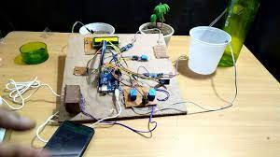

**CHAPTER 12**

**REFERENCES**

* <https://circuitdigest.com/microcontroller-projects/iot-based-smart-agriculture-moniotring-system>
* <https://youtu.be/MwIGkDKd3L4>
* [www.wikipedia.com](http://www.wikipedia.com)
* <https://www.researchgate.net/>
* <https://www.electronicsforu.com/>
* <https://www.ieee.org/>